Did you notice…? (Instructor Version)

**Instructor Note**: Red font color or Gray highlights indicate text that appears in the instructor copy only.

1. Objectives

Explain how a small network of directly connected segments is created, configured and verified.

Students will note how the networks differ, both in size and in function. They will identify how the networks provide different networking solutions based upon their cost, speed, ports, expandability and manageability as related to the needs of a small to medium-sized business.

1. Topology

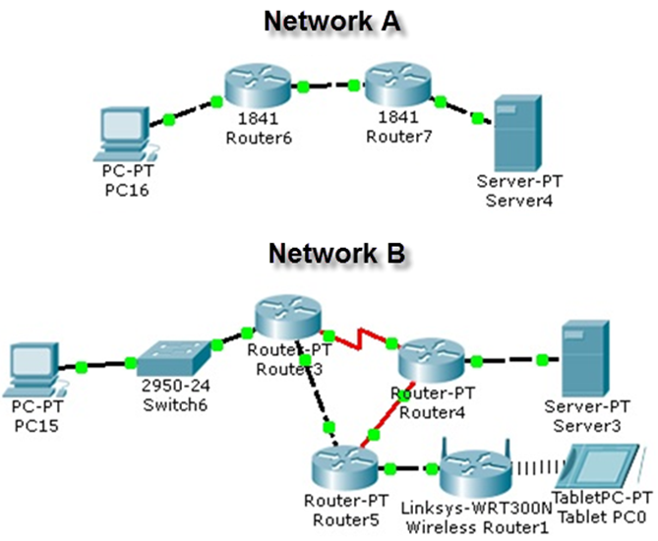

1. Background /Scenario

Take a look at the two networks in the topology diagram. Answer the following questions and record your answers to share with the class.

* Visually compare and contrast Network A and Network B. How are the two networks the same?
* Make note of the devices used in each network design. Because the devices are labeled, you already know what types of end and intermediary devices they are. How are the two networks different? Is the number of devices present in one network the only differentiating factor? Justify your answer.
* Which network you would select if you owned a small to medium-sized business. Justify your selected network based on cost, speed, ports, expandability, and manageability.

**Instructor notes**: This Modeling Activity is not intended to be a graded assignment. Rather students should note similarities and differences regarding the network equipment shown and the types of networks created. Addressing of the two networks should also be a factor in their comparisons of both networks. Facilitation of the discussion should include student-to-student discussions of each other’s work.

1. Required Resources

* Recording capabilities (paper, tablet, etc.) for reflective comments to be shared with the class.

1. Reflection
2. Reflect upon your comparisons of the two network scenarios. What are some things you noted as points of interest? ____________________________________________________________________________________

Multiple students may select Network B as their choice of the best network for a small to medium-sized business. But this may not necessarily be the best choice.

Network A is less costly in equipment. It also provides a more streamlined design, which should assist with network speed issues. Since there is no switch present in this particular network, expandability would be an issue and limited to the ports already present on the ISRs. Manageability would be easy, as there are fewer devices to keep documented and up to date.

Network B is more costly than A in equipment alone. It provides for redundancy which is important to the cost of performing business functions. It allows for wireless transmission not just Ethernet, as shown in Network A, but incorporating wireless technology increases the possibility of security breaches, which increases manageability considerations. Speed could be enhanced if the devices used load balancing and static routes to assist with load balancing. We do not know what types of Routers are included in Network B and if they are 1841 routers, data traffic could actually be slowed, but this depends on the route the network data travels.

Therefore, all categories considered, either network would be acceptable to use for a small to medium-sized business. Network A and B offer different positives and negatives, and it would be up to the small to medium-sized business to prioritize cost, speed, ports, expandability and manageability. They would eventually go on from their prioritization list with a look to the future and select the best design for the business. This is similar to separating all sessions into multiple conference rooms according to their topics.

**Identify elements of the model that map to real-world content:**

* Cost, speed, ports, expandability and manageability are all factors to consider when designing a small to medium-sized network.